Who Supplies Nuclear Capabilities to Iran?
Using dynamic network analysis to determine the most influential actors in the network

Alla G. Khadka¹, Ryan E. Franzer¹, Megan Thomas¹, Jeffrey L. Carasiti¹, Johanna E. Steenrod²

- University of Pittsburgh, Graduate School of Public and International Affairs
- University of Pittsburgh, Graduate School of Public Health, Health Policy Institute (HPI)

Abstract

The possibility of Iran developing a nuclear weapon is viewed as one of the greatest threats to global security. Iran’s nuclear program receives material, equipment, technology and expertise from suppliers around the world. Halting Iran’s efforts to develop nuclear weapons depends on tracking countries, organizations, and individuals that supply nuclear capabilities to Iran. In this study we employ dynamic social network analysis to map out the suppliers of nuclear capabilities to Iran and their contacts inside Iran as a network that evolves over time. To achieve this end, first, we create a comprehensive dataset that captures nuclear technology, material and knowledge that were supplied to Iran from 1985 to 2012. The primary data sources are the Wisconsin Project on Nuclear Arms Control’s “Iran Watch” dataset (Iran Watch, 2011), IAEA reports assessing Iran’s nuclear posture (e.g. IAEA, 2012); and the Nuclear Threat Initiative (NTI) publication on Nuclear Iran (NTI, 2011). We then process the dataset with the ORA program to elicit the Iran’s nuclear trade network. We employ centrality measures to assess the most influential members of the network (Freeman, 1978). Particular attention is paid to the ‘opinion leaders’ (nodes that have the highest out-degree centrality). Next, we evaluate the critical members of the network based on the type of material or expertise that they supply. Considering that two stages of nuclear capability cycle – Enrichment and Weaponization – specifically contribute to the development of nuclear weapons, we focus on the members of the network that are most central to empowering the weaponization of Iran’s nuclear program. Determining Iran’s most critical suppliers provides necessary insights for any policy directed at disrupting its nuclear capability.

Keywords: Social Network Analysis, centrality, Iran, nuclear program, nuclear trade network

Introduction

The possibility of Iran developing a nuclear weapon is viewed as one of the greatest threats to global security. Considering that Iran’s nuclear program receives material and expertise from suppliers around the world, the solution to halting Iran’s efforts to develop nuclear weapons depends on tracking countries, organizations, and individuals that supply it with nuclear capabilities. Much research has been conducted on various aspects of the Iran’s nuclear program. However, almost nothing exists on the assessment of Iran’s nuclear suppliers’ network. To fill this gap, in our study we map out and analyze the network of counties, organizations and individuals that transfer nuclear material, technology, equipment, and expertise to their contacts inside Iran.

To achieve this end, we collect data on the suppliers and the specific facilities within Iran with which each supplier interacts. The primary data sources used to compile the dataset are the Wisconsin Project on Nuclear Arms Control’s “Iran Watch” dataset (Iran Watch, 2011), IAEA reports assessing Iran’s nuclear posture (e.g. IAEA, 2012), and the Nuclear Threat Initiative (NTI) publication on Nuclear Iran (NTI, 2011). In addition to collecting data on specific organizations and individuals that supply nuclear material and expertise to Iran, we also gather information on each supplier’s country of origin, the type of material being transferred and the dates of the transactions. The temporal information allows us to observe how Iran’s nuclear trade network evolves over time. We utilize the ORA network analysis program (Carley et al., 2012) to perform data visualization and analysis of Iran’s nuclear trade network.

First, we evaluate the network members (countries, organizations and individuals), using social network analysis (SNA) to determine the most influential actors in the system. We assess each member’s position in the network based on their out-degree centrality, or their number of transactions with Iran, allowing us to determine the most active network members (Freeman, 1978). Next, we evaluate the suppliers in the network by the type of nuclear capabilities (material, expertise, technology and equipment) they supply. Considering that there are two stages of the nuclear capabilities cycle – Enrichment and Weaponization – that specifically contribute to the development of nuclear weapons, the aim is to identify the members of Iran’s nuclear trade network that target these two stages.

Determining Iran’s most critical suppliers provides necessary insights for policies directed at disrupting its nuclear capability. This study allows us to answer the following questions:

- Which individuals, organizations and countries supply nuclear material, expertise, technology and equipment to Iran?
- What stages of the nuclear capabilities cycle are the suppliers targeting?
- Which suppliers specialize in which types of nuclear material?
- Who are the suppliers targeting the Weaponization and Enrichment stages and which of them have been operating in the market for the past ten years?
- If we were to disrupt the network most effectively, which members should we target?

Answering these questions enables us to identify and track the most dangerous suppliers, providing critical insights for policies directed at preventing Iran from building its nuclear arsenal.

Background

Iran’s nuclear program is set up around sixteen nuclear facilities and nine other locations that regularly handle nuclear material. In addition to the current facilities, Iran has announced the construction of ten additional facilities (Kerr, 2009). However, it is not known whether these plants will actually be built or what their exact purpose will be. Presently, it is speculated that these facilities might include research reactors, enrichment plants, waste disposal facilities, power reactors, and other research laboratories. The international community, mainly concerned with Iran’s development of a nuclear weapon, is focused on its uranium enrichment facilities, heavy water reactors, the Tehran Research Reactor, and the Russian-built Bushehr power plant (IAEA, 2012). We will briefly review recent activities in each of these four areas.

First, Iran continues to enrich uranium for use in its power plants and research reactors (IAEA, 2012). To date, Iran has produced 6,876 kg of up to 5% U235 (for use in power plants) and 189 kg of up to 20% U235 (for use in research reactors) (IAEA, 2012). Enrichment levels above 20% U235 are banned by the Nuclear Non-Proliferation Treaty, and 90% U235 is considered weapons-grade, usable in nuclear bombs. In May 2012, samples taken at the Fordow Fuel Enrichment Plant (FEP) measured 27% U235, which the Iranians explained as an accidental side effect of its enrichment practices and beyond their control. After investigating, the IAEA found their explanation “not inconsistent” with their findings (IAEA, 2012). While this does not provide sufficient evidence that illegal enrichment is taking place, it exemplifies the inherent difficulty of monitoring a nuclear program. As further illustration, the international community knows that the Fordow FEP uses a system of 3,000 centrifuges to produce up to 20% U235, amounting to nearly a third of Iran’s 20% U235 production. Most of the remaining fuel at this level is produced at a FEP at Natanz. Production Hall A of Natanz uses 55 centrifuge cascades to convert fuel from 5% to 20% U235 (Crail, 2011). In other words, the activities of Production Hall A are known. However, there is also an area on the site know as Production Hall B and, as of 2012, Iran has refused to provide any information on this area (IAEA, 2012).

Second, the Iran Nuclear Research Reactor (IR-40) at Arak has come under scrutiny over its use of heavy water (Davenport, 2012). Heavy water reactors use heavy water (D₂O) as moderator and coolant. Because D₂O is an efficient moderator these reactors can operate on natural uranium fuel, which can be reprocessed to produce more accessible amounts of plutonium, giving Iran another source of fissile material (Carlson, 2009: 6). Israel and India have both used this type of heavy water technology, received from other countries, to create their nuclear arsenals (Iran Watch, 2012). Although international observers have not been permitted access to the heavy water plants, satellite images have shown that the sites are active (IAEA, 2012).

Third, the international community continues to be apprehensive about the Tehran Research Reactor (TRR), viewing it as a possible center for uranium reprocessing activity, which Iran has pledged to suspend. The declared purpose of TRR is to create medical isotopes and for training and research purposes (IAEA, 2012). However, TRR continues to draw attention because of its regular use of 20% U235. The reactor receives fuel shipments from other facilities in Iran, ranging from natural uranium to the 20% U235 used in its 5 MW reactor, with the most recent shipment delivered in late 2012 (IAEA, 2012). Despite the level of concern over the reactor’s reprocessing potential, repeated inspections by the IAEA have confirmed Iranian claims that TRR is not involved in reprocessing (IAEA, 2012).

Fourth, another point of concern that remains unresolved is Iran’s close ties with other nuclear powers. Particularly of interest is Iran’s relationship with Russia because Russia has provided Iran with extensive assistance in creating its nuclear program in the past. Russia is responsible for the construction of the Bushehr reactors, also providing assistance with fuel and material for this plant (IAEA, 2010: 7; NTI, 2011). The Bushehr plant is a possible source of fissile plutonium for Iran’s program. Through an agreement with Iran, Russia provides fuel rods to the Bushehr reactor and collects the depleted fuel from the Iranians. The plant was initially staffed by a joint Russian-Iranian staff with the Iranian engineers being trained at Russian institutes (Iran Watch, 2012). Russian companies were also instrumental in supplying necessary equipment to the plant as well. This use of the reactor is not possible based on Iran’s current facilities alone because they lack the specialized plant needed to extract plutonium from spent fuel (Iran Watch, 2012).

Less critical, but still significant are Iran’s relations with China. China’s direct contributions are uranium mining techniques and laser technology (Harold and Nader, 2012). Additionally, China also trained engineers at the Esfahan Nuclear Research Center in Iran. Indirectly, Chinese trade has helped the Iranian economy remain at a state that allows it to continue refinement process. As sanctions increased from the United States and United Nations, China expanded its trade with Tehran, shielding the economy from the worst of the sanctions (Harold and Nader, 2012). It is also believed that China and India may provide support to Iran’s program through the use of lucrative oil contracts (Shuja, 2004).

Despite the history of India and China supporting Iran’s nuclear program, their role has diminished to a relatively small group of rogue individuals and companies over the past five years. Both governments have publicly supported the efforts of the United States government to halt proliferation. While India subscribes to the notion that a nuclear Iran would be a threat to global security, its stance on the issue is largely self-interested and directed by India’s relations with the United States, France, and Canada. Since India is a non-signatory to the nuclear non-proliferation treaty, the NPT member states could restrict its access to materials necessary to India’s nuclear program. Through the years of what has been described as “responsible” use of its nuclear technology, India has made agreements with a number of nuclear and non-nuclear states, including the United States, France and Canada, to obtain its much-needed fuel for its reactors (Sasikumar, 2007). Continuing this commitment to tight controls over its nuclear material is essential to sustaining these relationships. China is also concerned with its global image, that would suffer if it were to support Iran’s nuclear proliferation (Shen, 2006). Growing oil demand in China raises its need for consistent trade partners in a stable Middle East, both of which would deteriorate if nuclear weapons were officially introduced to the region. Moreover, China needs to maintain a good relationship with its largest trade partner, the United States. Chinese support of Iran’s program would instantly strain Sino-American relations, with serious repercussions to both countries’ economies (Shen, 2006). As long as Chinese and Indian interests align against a nuclear Iran, support from their citizens is expected to remain minimal.

Although it is premature to conclude that Iran is developing a nuclear weapon, there is clearly a potential for it. In an effort to gain a more nuanced view of Iran’s nuclear posture, a recent study classified all the nuclear activities within Iran into thirteen stages and sub-stages of nuclear capabilities cycle (Abdulla, et al., 2011). For detailed information on stages and sub-stages framework, please see Data section and Appendix A. Examining what type of activities occurs at each stage and sub-stage demonstrated that the two primary areas of concern for the Iranian development of a nuclear weapon are the Weaponization and Enrichment stages (Abdulla, et al., 2011). In line with this premise, not all nuclear material, expertise, technology, and equipment are directed at creating a weapons program. Hence, focusing solely on whether or not a country is importing and researching nuclear materials misses the nuances of nuclear development. If all of a state’s efforts in nuclear science are focused, for example, on the Power and Research stage, then formulating a strategy of preventing proliferation becomes a costly waste of resources. On the other hand, policy makers and organizations tasked with preventing nuclear proliferation need to have a clear picture of all the activities that directly bolster Weaponization and Enrichment.

Theory and Method

We use social network analysis to map and analyze the networks of countries, organizations and individuals that supply nuclear material for Iran’s nuclear program. Over the past decade, social network analysis entered the fields of international relations and security studies, emerging as a potent tool for informing strategies to combat drug trafficking, acts of terrorism, proliferation of nuclear material and other types of illicit operations (Milward and Raab, 2009; Perliger and Pedahzur, 2011; DeServe, 2009). Using a network analysis approach in assessing criminal organizations and their activities allows us to reveal the areas of vulnerability in the communication structure of these organizations. This information is critical for destabilizing and disrupting criminal enterprises. One of the key premises of the SNA approach is that networks have an inherent structure. The structure is comprised of members of the network (nodes) and the connections (ties) between these nodes. The importance of a certain member to a network, or the member’s centrality, can be determined by examining the types of connections this node forms with other nodes. The most pertinent centrality assessments in security studies are the node’s degree centrality (both in-degree and out-degree) and betweenness centrality (Burt, 1992; Valente, 2010).

The degree centrality of a node is a measure of the number of connections it shares with other nodes (Bright et al., 2012). Members with high degree centrality are usually referred to as opinion leaders. In this context, an opinion leader or a node with a high number of ties has substantial power in that this node has the ability to control and mobilize the group’s resources (van der Hulst, 2009). Focusing solely on this measure can be problematic, as it only shows the number of the node’s connections without distinguishing between important and insignificant connections (Bright et al., 2012). Another attribute of influence is the exclusivity of one’s connections. Nodes are often deemed influential if they are positioned as brokers. Brokers are the members of the network that connect clusters that otherwise would not be connected (Burt, 1992). In this sense, they serve as bridges or middlemen. Brokers are characterized as having high betweenness centrality. Bridging independent entities with the network gives brokers a unique position to control the flow of information, goods, resources or services (Bright et al., 2012). In criminal networks, nodes with high betweenness centrality tend to be the members that facilitate communication between those that make decisions and those that carry out these decisions. Nodes with high degree centrality and high betweenness centrality scores are generally considered to be the most vital to the survival of a criminal organization (Perliger and Pedahzur, 2011).

Successful strategies aimed at thwarting criminal networks (including nuclear material proliferation networks) rely on understanding what disruptions will have the greatest impact on the system. One of the most efficient approaches to disrupting a criminal network is removing its leaders (Keller et al., 2012). This method is based on the assumption that leaders are vital to holding the network together. Focusing on removing leaders, however, can have unintended consequences. In loosely connected networks, which many illicit networks are, simply eliminating the leader can cause the disconnected fringes of the group to splinter off and form their own networks (Keller et al., 2012). These groups will learn from the mistakes of their predecessor and become more agile and adaptable, making it harder to disrupt them (Keller et al., 2012). Despite this potential drawback, there is a general consensus among the experts that removing the important members of a network will ultimately disrupt the group. This strategy can be more effective if several most influential members are targeted simultaneously. Moreover, the largest impacts occur when members that facilitate the flow of information and goods between members are removed, since it is hard to replace members possessing highly specialized knowledge, skills or connections (Bright et al., 2012).

The structure of the network in which the members operate will determine the impact of losing certain members. For example, networks are more vulnerable when the leaders are directly connected with low-ranking members, because captured peripheral member can expose these leaders (Bright et al., 2012). A network of loose associations, on the other hand, allows the group to more easily adapt to the loss of a member. Finally, a smaller network that is still growing and with weak ties between rank-and-file members will be more sensitive to the removal of a leader because the group needs to attract new members and form basic ties between members (Bright et al., 2012).

Considering the nature of our data, we determine the most active entities that supply the Enrichment and Weaponization stages. In this analysis we focus on opinion leaders, identified here as the nodes with the highest out-degree centrality. We are unable to examine broker nodes with the highest betweenness centrality because the open source documents and databases list all Iran’s connections as direct connections and do not specify any further affiliations to establish a broker relationship. Although we are not able to elicit every entity engaged in the nuclear trade with Iran, the available data allows us to determine the first ring of suppliers targeting Weaponization and Enrichment. Identifying and targeting this ring is the most effective way to disrupt the sectors of the nuclear program that are being developed for military purposes.

Model

The model employed in this study consists of three stages. The first step entails gathering data, a process that we describe in detail in a separate section below. Once the data is collected, all the material, equipment, technology and expertise in the dataset are classified according to the modified version of the Nuclear Threat Initiative classification scheme (NTI, 2011) resulting in the assignment of each entry in the dataset to a “stage” of the nuclear capabilities cycle. Next, we perform social network analysis by processing our data through ORA (Carley et al, 2012). ORA enables us to create and evaluate four networks: (1) a network of countries supplying nuclear capabilities to Iran linked to the facilities that they supply within Iran; (2) a network of countries connected to the specific stages of nuclear cycle that each country is supplying; (3) a network of individuals/organizations supplying nuclear capabilities to Iran linked with the facilities that they supply in Iran; and (4) a network of individuals/organizations supplying nuclear capabilities to Iran linked with the stages of the nuclear cycle that they supply. Each of the four networks can be visualized as static, depicting all the interactions that occurred in the period from 1985 to 2012 as one snapshot. The four networks can be also viewed as dynamic, when the evolution of network is traced from 1985 to 2012 and each year is visualized independently. After the four networks are elicited, we identify the most influential members of the network based on out-degree centrality. This allows us to determine the most active countries and the most active individuals/organizations. Finally, we evaluate which entities consistently target Enrichment and Weaponization stages.

The sequence of steps can be summarized as follows:
Figure 1: A flowchart that depicts the stages in the proposed methodology to determine a country’s nuclear trade network and the most influential suppliers

Data

In creating our dataset we began with data provided by the Wisconsin Project on Nuclear Arms Control on their Iran Watch website (iranwatch.org). The site contains an up-to-date list of Iran’s suppliers as well as descriptions of the type of capability provided and the time period the activity took place. We gathered the following data:

- The name of the supplier (individual or organization)
- The current location of the supplier (country)
- The type of capability - equipment, material, technology, and expertise - supplied
- The time period of the activity in question (i.e., when given materials were exported)
- The receiving entity within Iran (i.e., a particular organization or nuclear facility)
Next, we used reports from the International Atomic Energy Agency (IAEA 2010, 2011, 2012) and the NTI publication on Nuclear Iran (NTI, 2011) to cross-validate the information that we collected from Iran Watch and to add new data when such data was available. While Iran Watch provides very general information on recipients, both NTI and IAEA studies offer data on specific organizations and nuclear facilities within Iran to which materials are supplied. There were several instances, however, when Iran Watch listed a supplier engaged in suspicious activities with Iran without providing details of what was supplied. In an effort to reduce missing data, we turned to the following sources: Institute for Science and International Security (ISIS, 2008); Center for Strategic and International Studies (Cordesman & Seitz, 2009), Iran Nuclear (2005); Strategic Policy Consulting (Jafarzadeh, 2005); the Congressional Research Service (Katzman, 2010); the Center for Nonproliferation Studies (Koch & Wolf, 1998) and the American Enterprise Institute: Iran Tracker (Zarif, 2009). The resultant dataset contains the suppliers (individual, organization, country), the capability (material, expertise, technology and equipment) supplied, and the years that each transaction occurred. Information on the type of capability and the time period when the transaction occurred indicates the level of activity in supplying the nuclear program as well as the duration of the relationship with Iran. In this way, we insure that those suppliers that contributed the most material to the program are given the most weight in the network and that their status as a contributor is maintained over time.

Each transaction is classified into one of the thirteen stages of nuclear capabilities cycle based on the modified version of the NTI classification system for nuclear facilities, see Table 1 (Abdulla et al., 2012: 12; NTI, 2012: http://www.nti.org/country-profiles/israel/facilities/; Harney et al., 2006). The advantage of using this framework is that it adopts and expands other schemes that are exclusively based on the nuclear fuel cycle. Classifying each capability according to its corresponding stage allows us to show the suppliers that are crucial to creating a weapons program. We extended the NTI framework to incorporate a “Financial” category to capture transactions that involved providing funding for Iran’s nuclear program and an “Evading Sanctions” category. Some of the materials in our dataset are general in nature, including items such as common electrical equipment and automotive parts, and could not be assigned to a stage. This kind of material is classified as “Other” because we could not accurately assign it to any particular stage without adding unnecessary additional weight to that stage.

Table 1: Classification System for Nuclear Facilities
Regulatory | Reprocessing
Mining and Milling | Waste Management
Conversion | Research Development
Fuel Fabrication | Education and Training
Enrichment | Weaponization
Heavy Water Production | Financial
Research Reactors | Evading Sanctions
Power Reactors | Other

To ensure that the dataset was inclusive of all entities involved in the nuclear process, we also included suppliers whose activity was discovered and prevented by international law enforcement. Material that did not reach Iran was coded as “Intercepted.” While this material is not a part of Iran’s capabilities, the source of that material is still a part of Iran’s network of suppliers. Adding the “Intercepted” designation allowed us to maintain this supplier in the network while not including that material in Iran’s overall capabilities. The material that reached Iran successfully was coded as “Transferred.”

Analysis

The first network we analyze captures the interactions of organizations/individuals with fifteen plus one stages of nuclear program (see Table 2 and Appendix C). This network depicts all of the interactions documented in open source publications, occurring from 1985 to 2012 as one snapshot. A connection between a supplier and a stage ensues when an organization/individual transfers nuclear material or expertise to this specific stage. The entire network has fifty-eight suppliers. These suppliers create ninety-eight distinct links, which means that several entities transfer material to more than one stage. The network is not dense indicating that most of the organizations/individuals target only one or two stages. Furthermore, with the open source data, there are no middlemen in the network, and all suppliers are directly connected to Iran.

Table 2: Network of Suppliers Interactions with Nuclear Stages:

Network Level Measures
Measure | Value | Measure | Value
Node count | 74 | Degree centralization | 0.107
Link count | 98 | Closeness centralization | 0.003
Density | 0.018 | Eigenvector centralization | 0.457
Characteristic path length | 1
Network fragmentation | 0.155

Next, we analyze the network of countries that transfer nuclear capabilities to Iran (see Figure 2 and Table 3). In total, there are fifteen countries involved. China surfaces as the most active with forty-seven interactions, connected to 10 out of 16 stages of the nuclear capabilities cycle. Most of the capabilities supplied by China were transferred successfully, one transaction was intercepted (Weaponization stage) and two transactions remain in a process of negotiation (Conversion and Other stages). We also know from the suppliers-stages network (see Appendix C) that China has several different companies and individuals participating in black-market activities involving providing nuclear material and expertise to Iran. The two most active suppliers from China, Beijing Research Institute of Uranium Geology and China National Non-metallic Minerals Industry Corporation, however, are linked with stages that do not directly contribute to the weaponization of Iran’s nuclear program. Three of the players that deserve special attention are Li Fang Wei, an individual connected with the Weaponization and Electronic Equipment stages, Zhejiang Ouhai International Trade, linked with Enrichment, and Beijing Alite Technologies, which targets Weaponization.

Figure 2: Countries Supplying Nuclear Capabilities to Specific Nuclear Stages in Iran
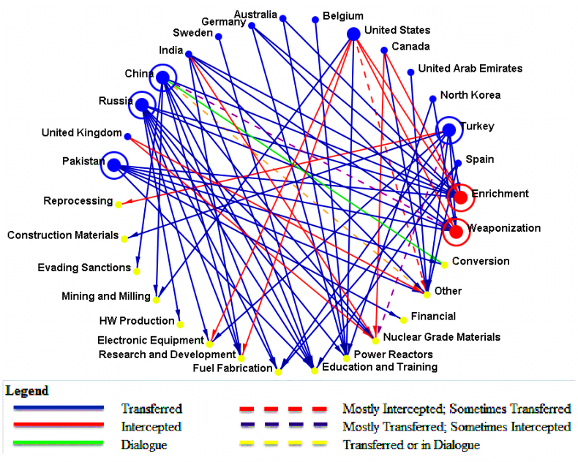

Table 3: Countries Supplying Nuclear Capabilities to
Specific Nuclear Stages in Iran Ranked by Frequency of Interactions
Rank | Country | Value | Unscaled
1 | China | 0.140 | 47
2 | Turkey | 0.113 | 38
3 | Russia | 0.098 | 33
4 | United States | 0.071 | 24
5 | India | 0.039 | 13
6 | Pakistan | 0.036 | 12
7 | Spain | 0.027 | 9
8 | Germany | 0.015 | 5
9 | United Kingdom | 0.015 | 5
10 | Canada | 0.012 | 4
11 | Australia | 0.006 | 2
12 | North Korea | 0.006 | 2
13 | Belgium | 0.003 | 1
14 | Sweden | 0.003 | 1
15 | United Arab Emirates | 0.003 | 1

The most active supplier after China is Turkey with 38 recorded interactions. Turkey is linked with eight stages, and all but two of its transactions were successful (Nuclear Grade Materials and Reprocessing stages). Although Turkey is active, there is only one company that operates from it, Step Standard Technical Part, and this company is notably linked with both the Weaponization and Enrichment stages. There are numerous individuals operating under the umbrella of Step Standard Technical Part. The next country on the list of the most active suppliers is Russia. Russia is connected with nine stages and all of its transitions were successful. Several Russian companies/institutes, including Atomenergoproekt State Planning and Design, Atomstroyexport (ASE), Baltic State Technical University and N.A. Dollezhal Research and Development Institute of Power Engineering (NIKIET) appear among the 15 most active suppliers (see Appendix B). Both Baltic State Technical University and NIKIET are connected with Weaponization, but the other two companies are connected to stages that do not directly contribute to the development of nuclear weapons. Similar to China, Russia has many companies that supply nuclear capabilities to Iran. In addition to Baltic State Technical University and NIKIET, five other companies from Russia are included in Iran’s network (see Appendix C). Furthermore, Moscow Bauman State University of Technology assisted Iran in building Shahab long-range missiles, directly contributing to the Enrichment stage.

The fourth most active actor involved in supplying nuclear capabilities to Iran is the United States, with 24 transactions. One of the major contrasts between the United States and all other suppliers is that most of its transactions were intercepted. Only two transactions, by Jirair Avanessian and Mercator, Inc., (Milling & Mining and Power Reactors stages) were successful. Two other countries that have considerably high interception rates are Canada and the United Kingdom. Another critical difference between the United States and other countries is that all but one of the suppliers are individuals instead of organizations. The most active individuals operating from the United States are Mir Hossein Ghaemi and Mohammad Reza Vaghari, who targeted Enrichment, Electronic Equipment, Research and Development and Other stages. Each of their transactions was intercepted and both individuals are no longer a part of the network.

Two less active, but still visible suppliers of Iran’s nuclear program are India and Pakistan with 13 and 12 interactions, respectively, over the past 30 years. Both India and Pakistan are connected with six phases, including Weaponization and Enrichment. Only one transaction from India was intercepted, and all transfers coming out of Pakistan were completed successfully. Among the most active participants from India are Dr. Y. S. R. Prasad, targeting Education & Training and Nuclear Grade Materials, and Dr. C. Surendar, linked with the Enrichment and Other stages. Nuclear Power Corporation of India Ltd. (NPCIL) is linked both with Enrichment and Weaponization, and Bharat Electronics Ltd. (BEL) and Projects and Development India, Ltd. (PDIL) from India are targeting Weaponization, which makes these three entities of concern. As expected, the main supplier from Pakistan is A. Q. Khan, surfacing as one of the most central and active participants in the network. He is connected to Weaponization and Enrichment as well as two other stages. There are two more suppliers operating from Pakistan – Aizaz Jaffery and Institute of Industrial Control Systems (IICS). Aizaz Jaffery is linked with Financial stage, which is not critical for our analysis, but the IICS is connected with Weaponization and Education & Training.

So far, we examined two static networks that encompass all transactions occurring from 1985 to present. Looking at 30 years of interactions visualized as a static network helps us to understand the overall dynamic of countries that supply nuclear capabilities to Iran. The next step is to assess each year as a separate network, paying particular attention to 2012 (See Figure 3). When assessing the evolution of interactions between suppliers and phases, we observe that the network is relatively stable with steady increase in the number of transactions per year until 1998. In 1998, the number of transactions leaps from 14 to 22 and in 1999, it increases to 34. This is the highest number of transactions during a single year between 1985 and 2012. From 1998 to 2006, the interactions between suppliers and Iran averaged 30 transactions per year. This number decreases to an average of 25 transactions per year in the period from 2006 to present. The year 2002 is the most active year after 1999, with 33 transactions.

Figure 3: Supplies Linked to Nuclear stages Network over time
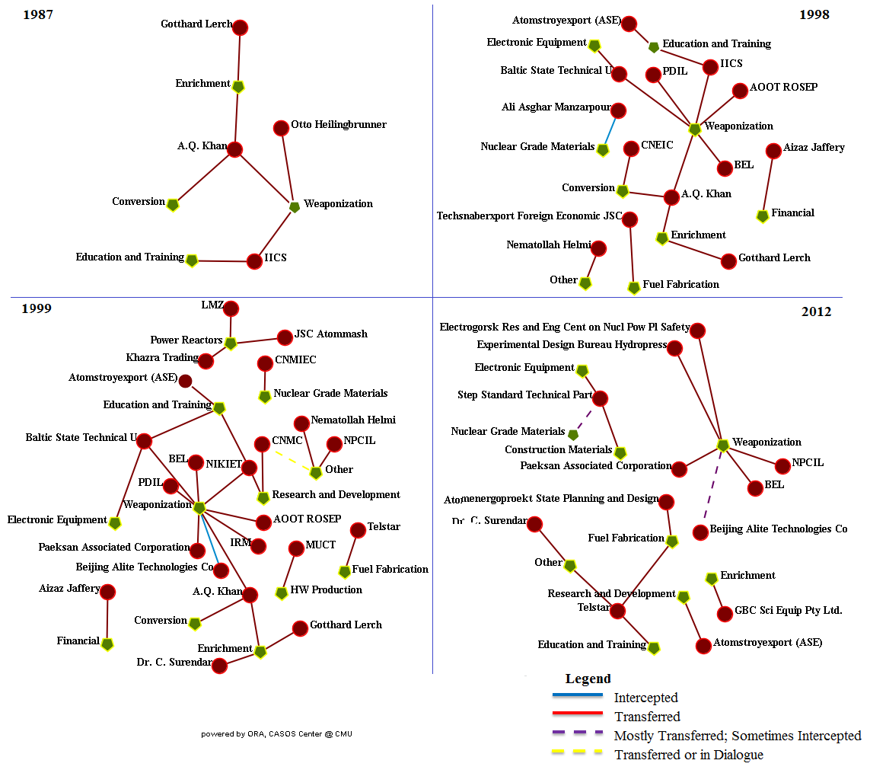

We notice that Weaponization is the most targeted destination stage for the entire period, beginning with 1987. From 1987 to 1990 the network is sparse, characterized by having only a few transactions per year. This period is marked with three central players – China (no information is available on specific companies operating from China), A. Q. Khan (Pakistan), and Gotthard Lerch (Germany). Entering the network in 1987, A. Q. Khan remains prominent until 2001. From 1987 to 2001 A. Q. Khan consistently targets Enrichment, Weaponization and Conversion stages. Additionally, he contributes to the Education & Training stage through the Dr. A.Q. Khan Research Laboratories, also known as Institute of Industrial Control Systems (IICS).

In 1991 the network grows to incorporate Milling & Mining and Research & Development stages, both supplied by China. In 1992 Russia and India enter the market with Russia supplying the Power Reactors and Enrichment stages, and India targeting Research and Development. From 1993 to 1997, more actors from Russia enter the market, while India completely disengages from the network, only to reappear in 1997. In the following two years, the network grows to reach its peak in 1999, when it consists of suppliers targeting 12 stages of nuclear capabilities cycle with the Weaponization stage being the most popular destination for transactions. There are nine actors targeting Weaponization, including three organizations from Russia, two organizations from India, one from North Korea, A.Q. Khan from Pakistan and one organization from China. The Enrichment stage in 1999 is supplied by A.Q. Khan and Gotthard Lerch, both connected with this stage since 1987. Enrichment is also targeted by Dr. C. Surrender from India. Between 1999 and 2012, Iran’s nuclear trade network has noticeably shrunk in size, falling from 22 suppliers in 1999 to only 12 by 2012. The suppliers that remain in 2012 target only 9 stages of nuclear program, while the larger 1999 network included suppliers active in 12 stages. In the past, it was common for network members to provide Iran with a variety of material and for most stages to receive support from multiple actors. The 2012 network, on the other hand, is mostly made up of single-purpose suppliers, and stages receiving the support of only one foreign entity.

Weaponization and Enrichment

In order to prevent Iran from achieving the status of nuclear weapons state, it is imperative to know who supplies nuclear capabilities to Iran. However, only two stages of nuclear program directly empower Iran in building its nuclear arsenal. We use this section to trace individuals and organization that supplied nuclear material or expertize to support Iran’s Weaponization and Enrichment activities from 1985 to 2012.

First, we assess the network of suppliers targeting Weaponization. Based on the data we collected from Iran Watch, Weaponization emerges as a destination for suppliers in 1987. In 1987, we have three actors: Otto Heilingbrunner from Germany, A. Q. Khan, and Institute of Industrial Control Systems (IICS), both from Pakistan. In 1988, Heilingbrunner drops out and Weaponization is supplied exclusively by Pakistan until 1993, when a Russian organization, Selenergoproekt Joint Stock Company (AOOT ROSEP), joins the network. In 1996, the group extended to include Baltic State Technical University from Russia and Bharat Electronics Ltd (BEL) from India in 1997. In 1998 Projects and Development India, Ltd. (PDIL) joins the group. The network of actors targeting Weaponization further expands in 1999 to incorporate Paeksan Associated Corporation from North Korea, N.A. Dollezhal Research and Development Institute of Power Engineering (NIKIET) (Russia), Beijing Alite Technologies Company (China), and Institute of Reactor Materials (IRM) (Russia). NIKIET immediately emerges as a supplier to three different stages. In addition to Weaponization it supplies material to Education & Training and Research & Development. In 2000, Khazra Trading (Russia) is added. A.Q. Khan’s departure is the only change that comes to the Weaponization network in 2002. In 2003 PDIL leaves the scene as well. The network expands again in 2004 to incorporate one more player from Russia, Experimental Design Bureau Hydropress, and another actor from Turkey, Step Standard Technical Part. Similarly to NIKIET, Step Standard Technical Part enters the market as a major player, engaging with Weaponization plus four other stages (Nuclear Grade Materials, Construction, Enrichment, Fuel Fabrication and Electronic equipment). In 2005 NIKIET withdraws from the network. Jamshid Ghassemi attempts to join the network in 2006; however, the United States intercepted all of his attempted transfers.

In 2007, the network shrinks to four suppliers - Paeksan Associated Corporation from North Korea, Beijing Alite Technologies Company, Experimental Design Bureau Hydropress and BEL. All other actors withdraw from the market completely, except for the Step Standard Technical Part, which remains active in the Electronic Equipment and Nuclear Grade Materials phases. It is important to note here that all countries that were supplying the Weaponization phase since 1998 remain active suppliers, although they are down to just one company per country. In 2008 Nuclear Power Corporation of India Ltd. (NPCIL) from India joins the market. Two new players join in 2009, including Electrogorsk Research and Engineering Center on Nuclear Power Plants Safety from Russia and Li Fang Wei from China. Interestingly, Li Fang Wei supplied the Nuclear Grade Materials phase upon his entry in 2007, but 2009 marks his first involvement in Weaponization. Also in 2009, the Step Standard Technical Part begins supplying Weaponization but stops after just one year. Furthermore, in 2010 Paeksan Associated Corporation disengages with Weaponization and switches to Power Reactors, and Li Fang Wei leaves the network completely. In 2011, Paeksan Associated Corporation drops Power Reactors and switches back to supplying Weaponization. No changes in the network occurred in 2012.

In 1987 the Enrichment stage had only two suppliers: A.Q. Khan (Pakistan) and Gotthard Lerch (Germany). This situation remained constant until 1992, when Moscow Bauman State University of Technology became the third supplier. These three suppliers fueled Iran’s enrichment program in 1993. They remained in the network in 1994, when China joined and became Iran’s fourth enrichment supplier. China participated for only one year, leaving A.Q. Khan, Gotthard Lerch, and Moscow Bauman State University of Technology as the only three suppliers from 1995 until 1997. In 1998, Bauman University dropped out, leaving just A.Q. Khan and Gotthard Lerch to supply the enrichment stage. Dr. C. Surendar (India) expanded the network to three suppliers again in 1999. By 2000, Dr. C. Surendar’s participation in enrichment ended, although he remained active in providing other materials to the nuclear program. In 2000 and 2001 A.Q. Khan and Gotthard Lerch were the only two individuals who remained active in supplying Enrichment.

The first major change to the Enrichment network came in 2002, when after 14 years of supporting this aspect of Iran’s nuclear program, A.Q. Khan left the network. Khan had also been a key supplier of Weaponization material throughout his period of activity. In his place, an American, Mohammad Reza Vaghari and German national Harold Hemming joined Gotthard Lerch in supporting enrichment activities. Hemming’s involvement lasted only one year, as he left the network in 2003, when the Australian company GBC Scientific Equipment Pty Ltd joined, holding the network at three members. The same three suppliers remained in the network in 2004. In 2005, Gotthard Lerch ended his 17 years of involvement in the network, leaving only GBC and Vaghari as contributors to the enrichment process. The network doubled to four suppliers in 2006, when the Nuclear Power Corporation of India Ltd. (NPCIL) and the Turkish company Step Standard Technical Part began supplying enrichment materials. The network dropped to three members in 2007, when Step Standard stopped supplying this kind of material, choosing instead to supply other phases of Iran’s nuclear program, most notably Weaponization. NPCIL ended its Enrichment support the next year and became a single-phase supplier of the Weaponization program. This makes the 2008 network identical to that of 2005, with only GBC and Vaghari. After six years of activity, Vaghari dropped out in 2009, and a Canadian, Mahmoud Yadegari began supplying in the same year, as he and GBC were the only two suppliers. In 2010, Yadegari left the network as well, and GBC was the only foreign supplier of enrichment material to Iran. Through 2011 and 2012, no other supplier emerged, leaving GBC only member of the current Enrichment network.

Conclusion

The source of Iran’s nuclear material and expertise has been obtained through legitimate and illicit means. Its status as a non-weapon nuclear state under the Nuclear Nonproliferation Treaty (NPT) allowed Iran to receive reactor components, including reactor fuel from nuclear states. It has used this status to build its first functional nuclear power plant with aid from Russia (Bowen and Brewer, 2011). In 2006, the United Nations Security Council banned any further assistance to Iran’s nuclear program under the NPT, imposing sanctions on any further assistance from the NPT states (Bowen and Brewer, 2011). However, the sanctions did not stop Iran from developing its nuclear program. At the same time, increasingly harsh sanctions and resource scarcity raise questions regarding the expectations of Iran’s future sources of material for its nuclear program. Iran has enough natural uranium to carry on research. Furthermore, it continues to produce growing quantities of LEU (IAEA, 2012). Declaring in 2011 their intention to “triple production capacity” of LEU, Iran’s government might be able to progress past the 20% threshold of LEU and advance to making weapons-grade uranium. Continued use of heavy water reactors could be interpreted as a source of fissile material, providing a covert route to plutonium acquisition (IAEA, 2011). As a result, international community has reasons to worry that Iran might exploit the dual-use nature of nuclear technology, advancing its enrichment program under the guise of “research” (IAEA, 2012).
Since the sanctions preclude Iran from receiving support for its program through legal channels, Iran has been obtaining nuclear material from international nuclear black-markets. The illicit shipping industry, despite setbacks, has been able to survive by spawning new companies to handle shipping and by using the “false flags” as authorities catch on (Iran Watch, 2012). To address Iran’s nuclear program effectively, it is critical to understand the nature of its illicit nuclear trade. In this paper, we have used social network analysis to map suppliers of nuclear material and expertise to Iran and their connections within Iran as a dynamic network.
Moreover, we posited that the two stages essential to building a nuclear arsenal are Weaponization and Enrichment, and, therefore, it is imperative to identify actors connected with these two stages. The results indicate that Enrichment is not a primary destination for nuclear materials in 2012. The network persisted mainly through the long term involvement of A.Q. Khan and Gotthard Lerch, each of whom supplied the program for more than a decade, as well as the efforts of GBC Scientific Pty Ltd and Mohammad Reza Vaghari, which sustained the enrichment process through much of the 2000s. While the focus now seems to have shifted away from enrichment, as GBC is the only remaining supplier, other agents that contributed to the network have moved to other areas of nuclear development. Dr. C Surendar, Step Standard Technical Part, and Nuclear Power Corporation of India Ltd have shifted their focus to other projects including, most alarmingly, Weaponization.
While the number of transactions to the Weaponization stage has dropped since 1999, Weaponization remains the most targeted nuclear stage, receiving support from several foreign organizations. As of 2012 there are six organizations active in supplying Weaponization: Paeksan Associated Corporation (North Korea), Beijing Alite Technologies Company (China), Experimental Design Bureau Hydropress (Russia), Electrogorsk Research and Engineering Center on Nuclear Power Plants Safety (Russia), Bharat Electronics Ltd (India) and Nuclear Power Corporation of India Ltd (India). From suppliers who were previously connected to Weaponization, we still observe that Step Standard Technical Part is an active supplier of other stages. Those seven entities are particularly important to target in order to preclude Iran from weaponizing its nuclear program.

On a positive note, when examining the overall network, we observe that it has become much less populated than in the period from 1998 to 2002. The fact that we see individuals and big companies leaving the market is encouraging and a trend that should be continued. A final point regarding Iran’s nuclear trade network is its shift from individual suppliers to organizations. In1999 Iran’s nuclear trade network included a number of prominent individuals, most notably A.Q. Khan and Gotthard Lerch, however, by 2012 these individuals had left the scene. Currently, with the exception of Dr. C. Surendar, the network is made up of large organizations. In this paper we identified the organizations fueling the Weaponization and Enrichment stages. The next step is to research the composition of these organizations.

Appendix A: Stages and Sub-Stages of Nuclear Cycle

Source: Abdulla et al., 2012; NTI, 2012: http://www.nti.org/country-profiles/israel/facilities/; Harney et al., 2006
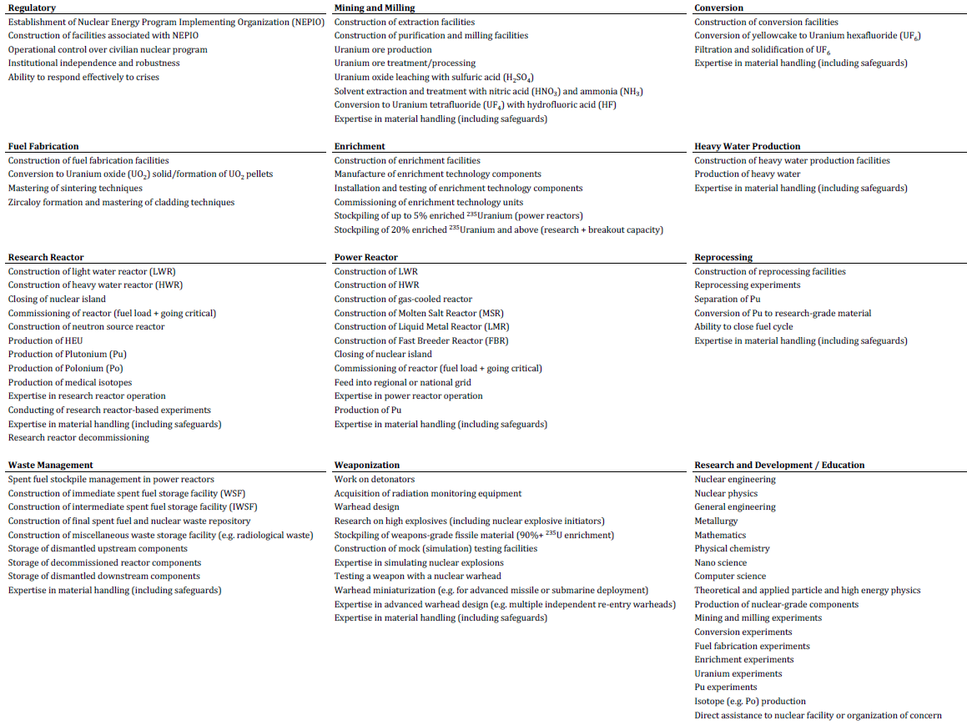

Appendix B: Suppliers Interactions with Nuclear Phases Network: Top Scoring Nodes
Rank | Betweenness centrality | Eigenvector centrality | In-degree centrality | Out-degree centrality | Total degree centrality
1 | GBC Sci Equip Pty Ltd. | Weaponization | Weaponization | Step Standard Technical Part | Weaponization
2 | Jacques Monsieur | Other | Other | China | Other
3 | Mahmoud Yadegari | Enrichment | Enrichment | A.Q. Khan | Enrichment
4 | Nematollah Helmi | Step Standard Technical Part | Education and Training | Mohammad Reza Vaghari | Education and Training
5 | Beijing Alite Technologies | Education and Training | Power Reactors | NPCIL | Power Reactors
6 | BIGAMRSRC | A.Q. Khan | Nuclear Grade Materials | Atomenergoproekt State Planning and Design | Step Standard Technical Part
7 | BRIUG | NPCIL | Research and Development | Atomstroyexport (ASE) | Nuclear Grade Materials
8 | CNMIEC | China | Fuel Fabrication | Baltic State Technical U | Research and Development
9 | CNMC | Mohammad Reza Vaghari | Electronic Equipment | NIKIET | Fuel Fabrication
10 | CNEIC | Baltic State Technical U | Conversion | Telstar | China
11 | Li Fang Wei | NIKIET | Mining and Milling | GBC Sci Equip Pty Ltd. | A.Q. Khan
12 | Seibow Limited | Telstar | Evading Sanctions | Mahmoud Yadegari | Mohammad Reza Vaghari
13 | TFT | Dr. C. Surendar | Financial | BRIUG | NPCIL
14 | Zhejiang Ouhai Int Trade | Nuclear Grade Materials | HW Production | CNMC | Atomenergoproekt State Planning and Design
15 | China | IICS | Construction Materials | Li Fang Wei | Atomstroyexport (ASE)
16 | Eva-Marie Hack | Power Reactors | Reprocessing | Dr. C. Surendar | Baltic State Technical U

Appendix C: Individuals/Organizations Supplying Nuclear Capabilities to Specific Nuclear Stages
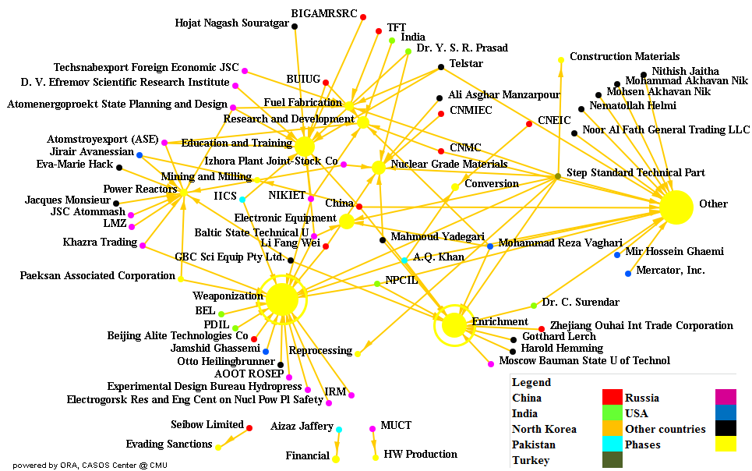

Bibliography
Abdulla, Ahmed, Alla G. Khadka, Miray Kas, William Frankenstein, L. Rick Carley, and Kathleen M. Carley. 2012. Nuclear Security and Iran: Developing a Methodology to Assess a Country’s Nuclear Capability. Midwest Political Science Conference 2012, at Chicago, IL.
Borger, Julian. 2013. “Iran heavy water plant revealed – again: 'Revelations' about Arak site are nine years old.” Julian Borger's Global Security Blog. February, 27. Guardian News and Media Limited. Available from: http://www.guardian.co.uk/world/julian-borger-global-security-blog/2013/feb/27/iran-nuclear-arak-heavy-water.
Bowen, Wyn Q., and Jonathan Brewer. 2011. "Iran's Nuclear Challenge: Nine Years and Counting." International Affairs no. 87 (4):75-82.
Bright, David, Caitlin Hughes, and Jenny Chalmers. 2012. "Illuminating Dark Networks: A Social Network Analysis of an Australian Drug Trafficking Syndicate." Crime, Law and Social Change no. 57 (2):151-176.
Burt, Ronald S. 1992. Structural Holes: The Social Structure of Competition. Cambridge, MA: Harvard University Press.
Carlson, John. 2009. “Introduction to the Concept of Proliferation Resistance.” ICNND Research Paper No. 8, Revised (3 June). Australian Safeguards and Non-Proliferation Office.
Cirincione, Joseph. 2006. "Controlling Iran's Nuclear Program." Issues in Science and Technology no. 22 (3):75-82.
Cordesman, Anthony H., and Adam C. Seitz. 2009. Iranian Weapons of Mass Destruction: The Birth of a Regional Nuclear Arms Race? Santa Barbara, CA: Center for Strategic and International Studies: ABC-CLIO, LLC.
Crail, Peter. 2011. Iran prepares improved centrifuges. Arms Control Today, 2011/04//, 22+.
Davenport, Kelsey. 2012. Iran moves forward on nuclear facilities. Arms Control Today, 2012/12//, 23+.
DeServe, Edward G. 2009. "Integration of Innovation in the Intelligence Community: The Role of the Netcentric Environment, Managed Networks, and Social Networks." In Unlocking the Power of Networks: Keys to High Performance Government, edited by Stephen Goldsmith and Donald F. Kettl, 121-143. Washington, D.C.: Brookings Institution.
Everton, Sean F. 2012. Disrupting Dark Networks: Structural Analysis in the Social Sciences. New York: NY: Cambridge University Press
Freeman, Linton C. 1978. "Centrality in Social Networks Conceptual Clarification." Social Networks no. 1 (3):215-239.
Harney, R., G. Brown and M. Carlyle. (2006). “Anatomy of a Project to Produce a First Nuclear Weapon.” Science and Global Security, Vol. 14: 163–182.

Harold, Scott Warren, and Alireza Nader. 2012. China and Iran: Economic, Political, and Military Relations. Santa Monica, CA: RAND Corporation.
International Atomic Energy Agency (IAEA). 2005. Country Nuclear Fuel Cycle Profiles. Technical Report Series No. 425. Available from http://www-pub.iaea.org/MTCD/publications/PDF/TRS425_web.pdf.
International Atomic Energy Agency (IAEA). 2009. Nuclear Fuel Cycle Information System:A Directory of Nuclear Fuel Cycle Facilities. IAEA-TECDOC-1613. Available from http://www-pub.iaea.org/mtcd/publications/pdf/te_1613_web.pdf.
International Atomic Energy Agency (IAEA). 2010. Implementation of the NPT Safeguards Agreement and Relevant Provisions of Security Council Resolutions in the Islamic Republic of Iran. Report: GOV/2010/46 (September 6). Available from http://lewis.armscontrolwonk.com/files/2010/09/GOV_2010_46.pdf
International Atomic Energy Agency (IAEA). 2011. The Nuclear Fuel Cycle. Available from http://www.iaea.org/OurWork/ST/NE/NEFW/_nefw-documents/NuclearFuelCycle-lowres.pdf.
International Atomic Energy Agency (IAEA). 2012. Implementation of the NPT Safeguards Agreement and Relevant Provisions of Security Council Resolutions in the Islamic Republic of Iran. Report: GOV/2012/37: International Atomic Energy Agency.
Institute for Science and International Security (ISIS). 2008. Nuclear Iran: Nuclear Sites: Physics Research Center [cited December 30, 2012]. Available from http://www.isisnucleariran.org/sites/detail/physics-research-center/.
Iran Nuclear. 2005. Defense Ministry and the Revolutionary Guards Engaged in Production of Centrifuges in the Past Few Months [cited December 30, 2012]. Available from http://irannuclear.org/index.php?option=com_content&task=view&id=31&Itemid=1.
Iran Watch. 2011. Iran Suspect Entities. Wisconsin Project on Nuclear Arms Control [cited December 30 2012]. Available from http://www.iranwatch.org/suspect/.
Iran Watch 2012. Troubled Waters: An Update on Iran’s Sanctioned State Shipping Line. Wisconsin Project on Nuclear Arms Control. Available from http://www.iranwatch.org/enforcementnotebook/irisl-sanctions-impact-080212.htm.
Jafarzadeh, Alireza. Iran Hiding a Laser Enrichment Facility Underground in Parchin Military Complex. Strategic Policy Consulting (SPC), (March 24) 2005 [cited December 30, 2012]. Available fromhttp://spcwashington.com/?p=756.
Katzman, Kenneth. 2010. Iran: U.S. Concerns and Policy Responses. Congressional Research Service, Report: RL32048 (July 23, 2010).
Keller, Jared P, Kevin C. Desouza, and Yuan Lin. 2012. "Dismantling Terrorist Networks: Evaluating Strategic Options Using Agent-Based Modeling." Technological Forecasting and Social Change no. 77 (7):1014-1036.
Kerr, Paul K. 2009. "Iran's nuclear program: status." Library of Congress Washington DC Congressional Research Service. Available from http://www.fas.org/sgp/crs/nuke/RL34544.pdf.
Koch, Andrew, and Jeanette Wolf. Iran’s Nuclear Facilities: A Profile. Center for Nonproliferation Studies (CNS), Monterey Institute of International Studies 1998. Available fromhttp://cns.miis.edu/reports/pdfs/iranrpt.pdf; For appendix of a table on selected Iranian nuclear imports see: http://cns.miis.edu/reports/pdfs/irantbl.pdf
Milward, H. Brinton, and Jörg Raab. 2009. "Dark Networks and the Problem of Islamic Jihadist Terrorism." In Unlocking the Power of Networks: Keys to High Performance Government, edited by Stephen Goldsmith and Donald F. Kettl, 168-189. Washington, D.C.: Brookings Institution.
Nuclear Threat Initiative (NTI). 2011. Iran: Nuclear. James Martin Center for Nonproliferation Studies; Monterey Institute of International Studies [cited December 30, 2012. Available from http://www.nti.org/country-profiles/iran/nuclear/
Nuclear Threat Initiative (NTI). 2012. Israel: Nuclear Facilities. James Martin Center for Nonproliferation Studies; Monterey Institute of International Studies. Available from http:// http://www.nti.org/country-profiles/israel/facilities/
Perliger, Arie, and Ami Pedahzur. 2011. "Social Network Analysis in the Study of Terrorism and Political Violence." Political Science & Politics no. 44 (1):45-50.
Sasikumar, Karthika. 2007. "India's Emergence as a "Responsible" Nuclear Power." International Journal of Human-Computer Studies no. 62 (4):825-844.
Shen, Dingli. 2006. "Iran's Nuclear Ambitions Test China's Wisdom." The Washington Quarterly no. 29 (2):55-66.
Shuja, Sharif. 2004. "Warming Sino-Iranian Relations: Will China Trade Nuclear Technology for Oil?" The Jamestown Foundation, China Brief no. 5 (12).
Valente, Thomas W. 2010. Social Networks and Health: Models, Methods, and Applications. New York, NY: Oxford University Press.
Van der Hulst, Renée. 2009. "Introduction to Social Network Analysis (SNA) as an Investigative Tool." Trends in Organized Crime no. 12 (2):101-121.
Zarif, Maseh. 2009. Locations of Iran’s Nuclear Program. Iran Tracker. American Enterprise Institute. (July 24). Available from http://www.irantracker.org/nuclear-program/locations-irans-nuclear-program#parchin

D₂O has a heavier hydrogen isotope, deuterium (having one proton and one neutron), which exists naturally in the proportion of around 1:6400 of hydrogen in water (Carlson, 2009: 6).
Plutonium is produced in the fuel of all uranium-fueled reactors, but remains in spent fuel unless separated by reprocessing (Carlson, 2009: 6). In the case of Arak Nuclear Research Reactor it does not produce radioactive material, but heavy water (D₂O), which can then be used to moderate uranium fission in a reactor under construction nearby. Spent fuel from the reactor could then be reprocessed to produce plutonium, which can in turn be used to make smaller, more powerful nuclear warheads than highly enriched uranium. However, Iran is a long way from that point (Borger, 2013).

